2024

Australian Service Excellence Awards

Organisation Category Nomination Questionnaire

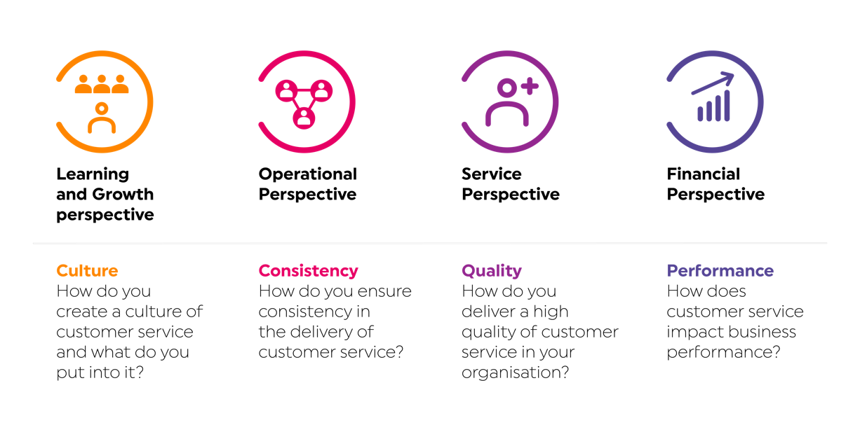

|  |
| --- |
| **2024 Australian Service Excellence Awards Organisation Nomination Questionnaire** |
| Instructions  Thank you for entering the 2024 Australian Service Excellence Awards Program. We are delighted that you are choosing to recognise service excellence and commend you for submitting a nomination.   * Please complete all sections of this form. * Once completed this form must be submitted to CSIA through the online awards nomination portal which can be found at [www.csia.com.au/awards](http://www.csia.com.au/awards) * Please complete a separate form for each nomination. * This form is for organisation category nominations only. Nominations for individual categories can be made using the 2024 Australian Service Excellence Awards Organisation Nomination Form. |
| Judging Criteria  The five sections below should be used to explain the role of the individual nominee, and why you feel they should be considered for the relevant award category.  The questions that we ask are related to the core elements of the International Customer Service Standard (ICSS: 2020-2025). We’d recommend reviewing the Standard as a way of familiarising yourself with some of the issues and factors that may be considered in judging your submission. Where possible, please provide specific examples of how the nominee has delivered against the core elements of the Standard, as referenced below: |

|  |
| --- |
| Section 1: Nomination Information  Please provide the following information: |
| Organisation name:  Category for this nomination: |
| Section 2: Nomination Overview  Please provide an explanation of your organisation, team, project or contact centre and why you feel that they should be considered for an award (approximately 250 words). |
|  |

|  |
| --- |
| Section 3: Learning & Growth Perspective  How has your organisation, team, project or contact centre created a culture of customer service? In this section, you may also wish to outline how the skills and talents of staff are improved to deliver superior customer service, for example learning and development programs, reward and recognition initiatives, and any specific recruitment methodology you follow. In addition, you may wish to highlight what and how technology is leveraged to create positive customer experiences (approximately 250 words). |
|  |

|  |
| --- |
| Section 4: Operational Perspective  What ways of working are implemented within your organisation, team, project or contact centre to ensure that a consistent level of superior customer service is delivered? What mechanisms and systems are in place to ensure a better level of customer service? How is the quality of customer service measured? If applicable, how have you ensured after sales service is delivered? (approximately 250 words). |
|  |

|  |
| --- |
| Section 5: Service Perspective  In this section, you may wish to outline how your organisation, team, project or contact centre collaborates with customers, suppliers and partners to deliver a better quality of product or service. If applicable, how have you used market trends and industry best practice to deliver better customer service? You may like to include how long-term relationships with customers have been built, how complaints are handled, how customer insights are collected, and how these insights are used for continuous improvement purposes (approximately 250 words). |
|  |

|  |
| --- |
| Section 6: Finance and Governance Perspective  How has your organisation, team, project or contact centre created growth in revenue, cost efficiencies and profit for the organisation in delivering superior customer service? If applicable, you may wish to highlight how corporate social responsibility has played a role in this (approximately 250 words). |
|  |