2024

Australian Service Excellence Awards

Individual Category Nomination Questionnaire

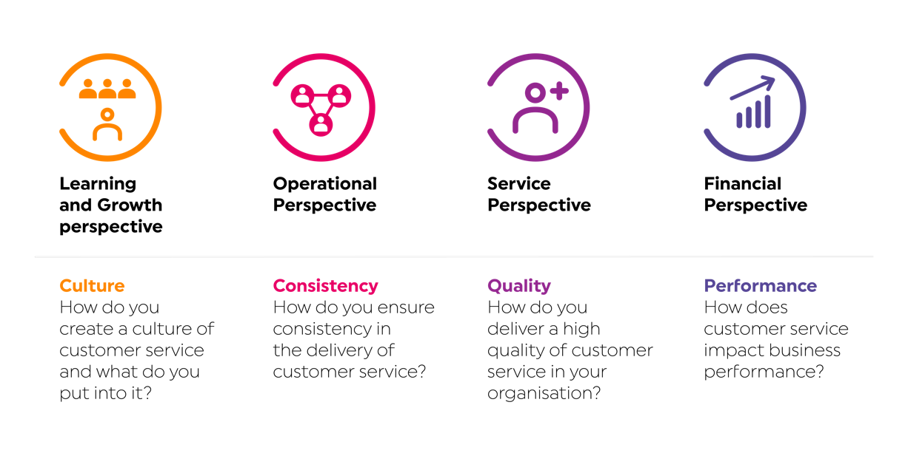

|  |
| --- |
| **2024 Australian Service Excellence Awards Individual Category Nomination Questionnaire** |
| Instructions  Thank you for entering the 2024 Australian Service Excellence Awards Program. We are delighted that you are choosing to recognise service excellence and commend you for submitting a nomination.   * Please complete all sections of this form. * Once completed this form must be submitted to CSIA through the online awards nomination portal which can be found at [www.csia.com.au/awards](http://www.csia.com.au/awards) * Please complete a separate form for each nomination. * This form is for individual category nominations only. Nominations for organisation categories can be made using the 2024 Australian Service Excellence Awards Organisation Nomination Form. |
| Judging Criteria  The five sections below should be used to explain the role of the individual nominee, and why you feel they should be considered for the relevant award category.  The questions that we ask are related to the core elements of the International Customer Service Standard (ICSS: 2020-2025). We’d recommend reviewing the Standard as a way of familiarising yourself with some of the issues and factors that may be considered in judging your submission. Where possible, please provide specific examples of how the nominee has delivered against the core elements of the Standard, as referenced below: |

|  |
| --- |
| Section 1: Nomination Information  Please provide the following information: |
| Nominee name:  Organisation name:  Category for this nomination: |
| Section 2: Nomination Overview  Please provide an explanation of the nominee's role and why you believe that they should be considered for the award (approximately 250 words). |
|  |

|  |
| --- |
| Section 3: Learning & Growth Perspective  How has the nominee improved the skills and talents of themselves and those around them in their role? How have they contributed to the organisation delivering customer service excellence? Review this perspective in the Standard as a way of familiarising yourself with some of the issues and factors that may be considered in judging your submission. Be sure to provide specific examples of how the nominee has delivered against the core elements of this perspective in the Standard (approximately 250 words). |
|  |

|  |
| --- |
| Section 4: Operational Perspective  How has the nominee ensured a consistent level of customer service within the organisation? How has the nominee innovated in their role to ensure a better level of customer service? How have they contributed to after sales service delivery, if applicable? Review this perspective in the Standard as a way of familiarising yourself with some of the issues and factors that may be considered in judging your submission. Be sure to provide specific examples of how the nominee has delivered against the core elements of this perspective in the Standard (approximately 250 words). |
|  |

|  |
| --- |
| Section 5: Service Perspective  How has the nominee worked with customers, suppliers and partners to deliver a better quality of product or service for the organisation? If applicable, how have they used market trends and industry best practice to deliver better customer service? How have they built long-term relationships with customers? Review this perspective in the Standard as a way of familiarising yourself with some of the issues and factors that may be considered in judging your submission. Be sure to provide specific examples of how the nominee has delivered against the core elements of this perspective in the Standard (approximately 250 words). |
|  |

|  |
| --- |
| Section 6: Finance and Governance Perspective  How has the nominee created growth in revenue, cost efficiencies and/or profit for the organisation in delivering superior customer service? If applicable, how has corporate social responsibility played a role in what they do? Review this perspective in the Standard as a way of familiarising yourself with some of the issues and factors that may be considered in judging your submission. Be sure to provide specific examples of how the nominee has delivered against the core elements of this perspective in the Standard (approximately 250 words). |
|  |